DaVim Rendering Engine Walkthough

All your files pertaining to the project should be placed inside the release folder.

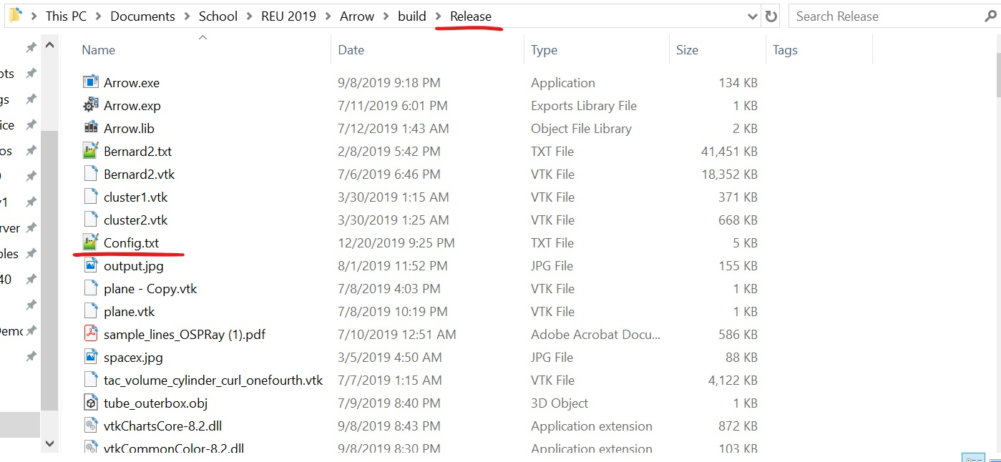

Main starts near the bottom.

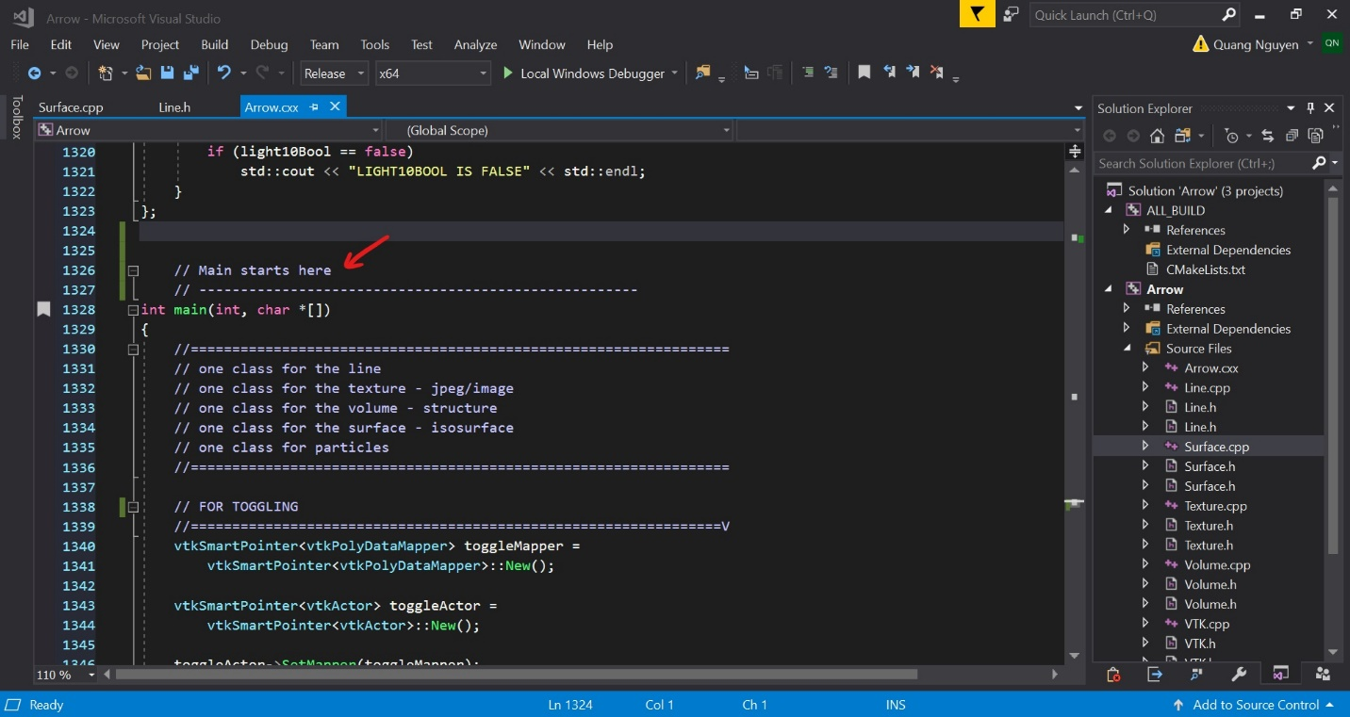

Within the main, the configuration file “Config.txt” is initially opened and all inputs are taken in.

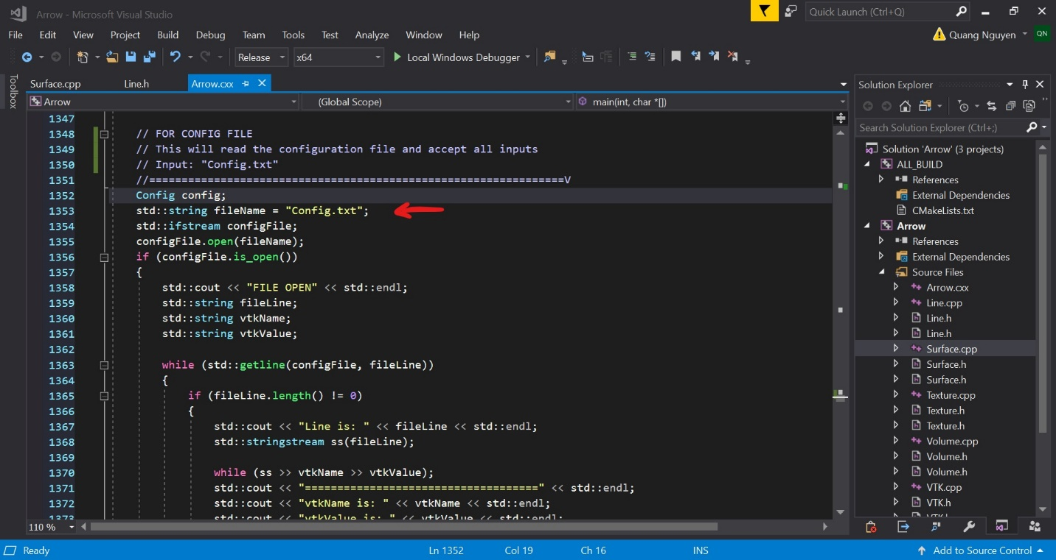

From the configuration file, if the booleans are true, the functions are called.

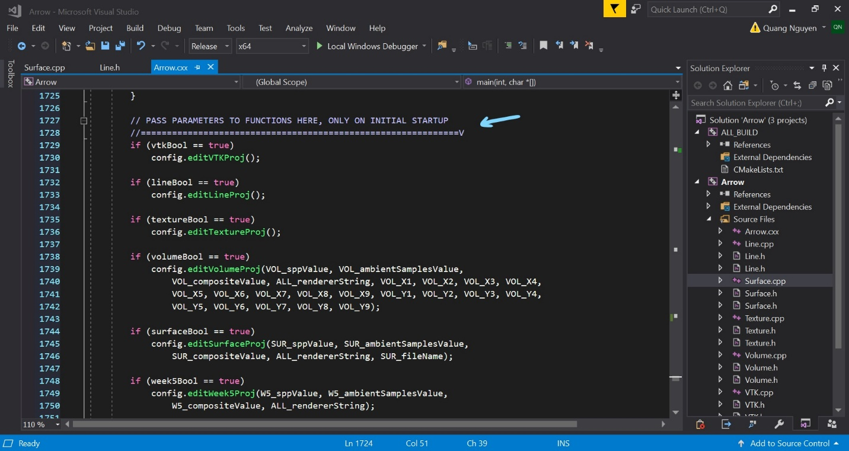

The flow of the code the goes back to the top.

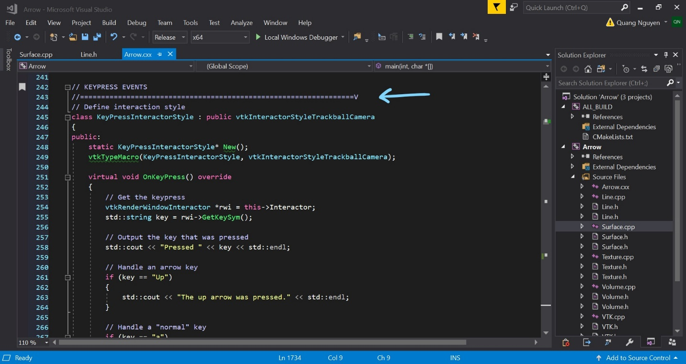

Configuration file is reopened and retakes all values in case of changes.

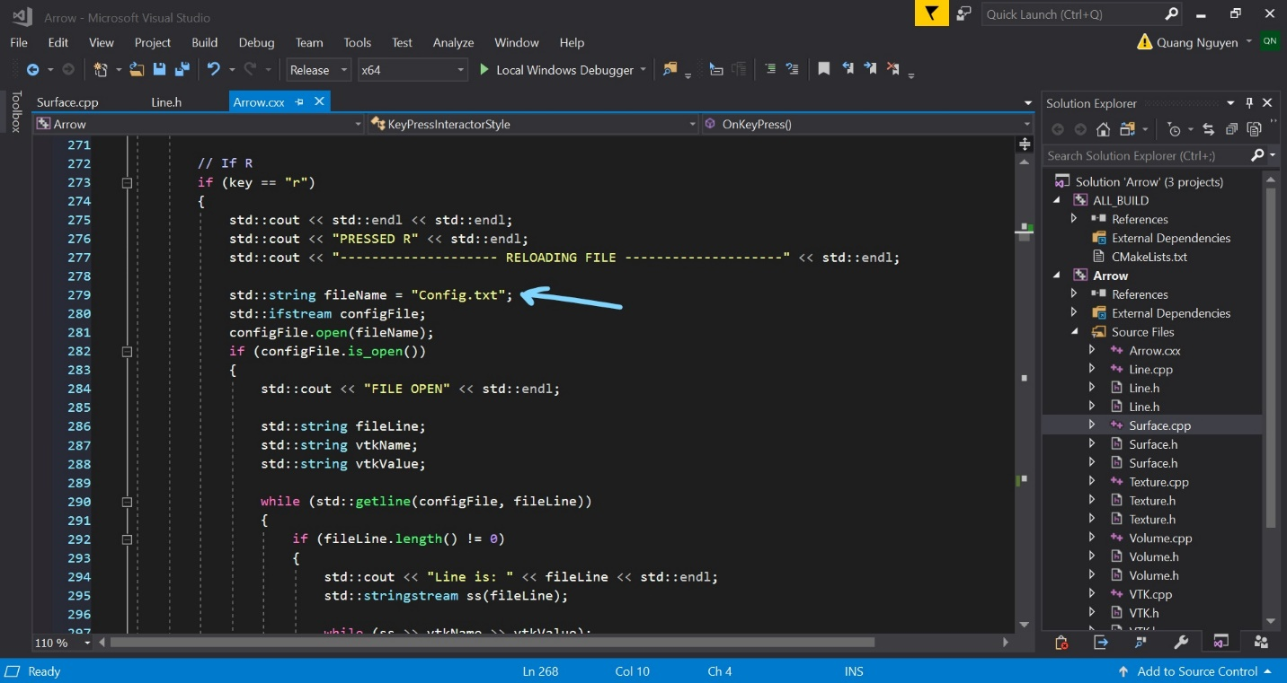

Now all the parameters are being passed to their functions. So, make sure your file names are correct.

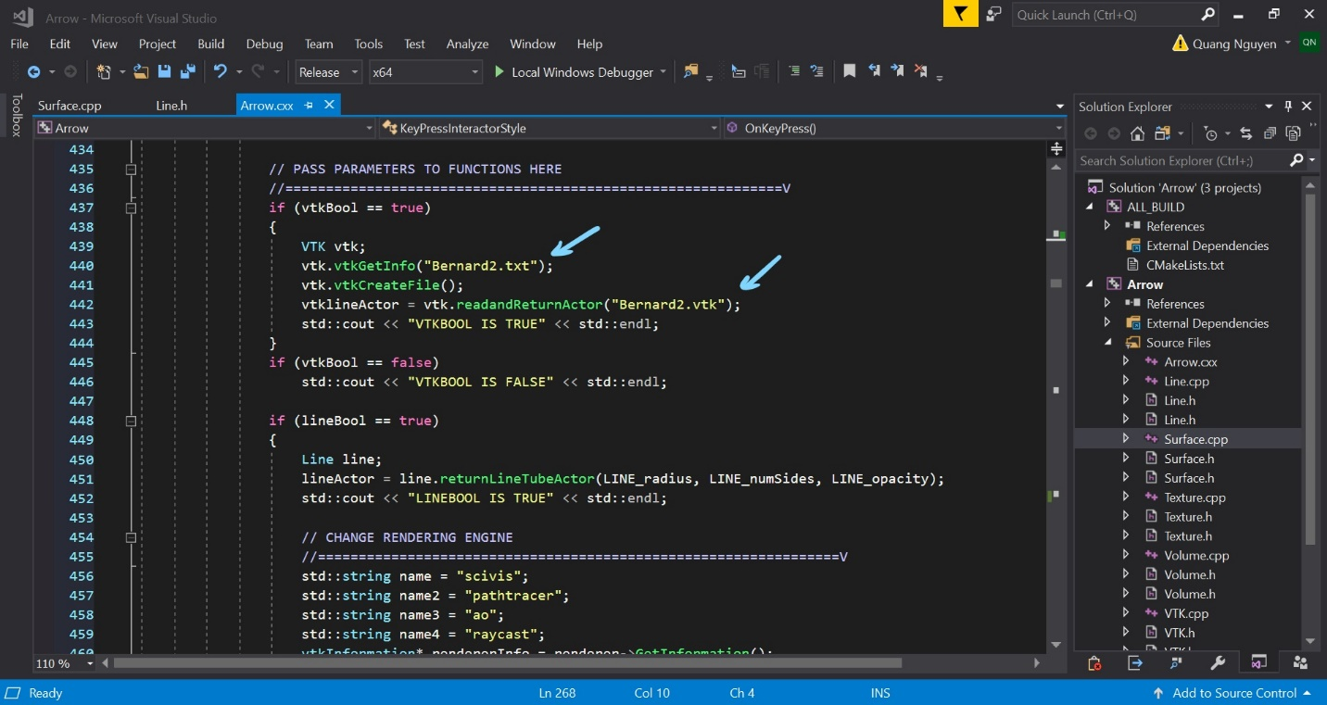

For QT, all the program code lies in a function called “arrowClickMe.”

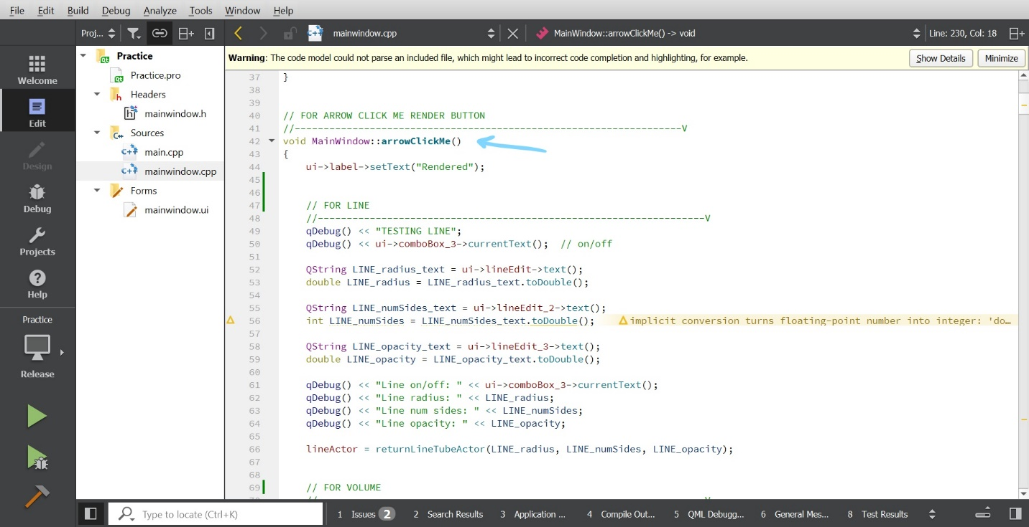

Like a typical C++ class, the functions are declared in the header.

